**What the program does?**

“Finding Root” program is finding the root of the given equation with one of three methods which are “Bisection Method”, “Newton Raphson Method” and “Secant Method”.

**What are these methods?**

These are root-findin algorithms.

**Bisection Method**

The bisection method is used to find the roots of a polynomial equation. It separates the interval and subdivides the interval in which the root of the equation lies. The principle behind this method is the intermediate theorem for continuous functions.

**Newton Raphson Methos**

The Newton Raphson method is used to quickly find a good approximation for the root of a real-valued function f ( x ) = 0 f(x) = 0 f(x)=0. It uses the idea that a continuous and differentiable function can be approximated by a straight line tangent to it.

**Secant Method**

The secant method is a used to a succession of roots of secant lines to better approximate a root of a function f. The secant method can be thought of as a finite-difference approximation of Newton's method.

**How The Program Works?**

In the program, there are 3 radio buttons and each one represents one of the methods. Bisection method is selected by default. When you select other methods the GUI is changing and new elements are showing to the user.

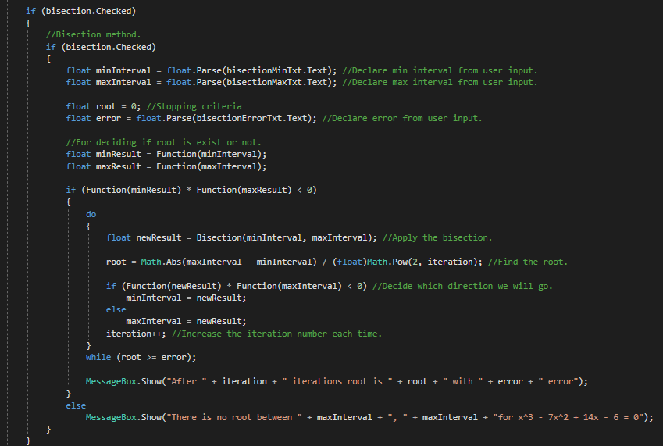

Codes in the first image for bisection method. It applies the method until the root is smaller than acceptable error.

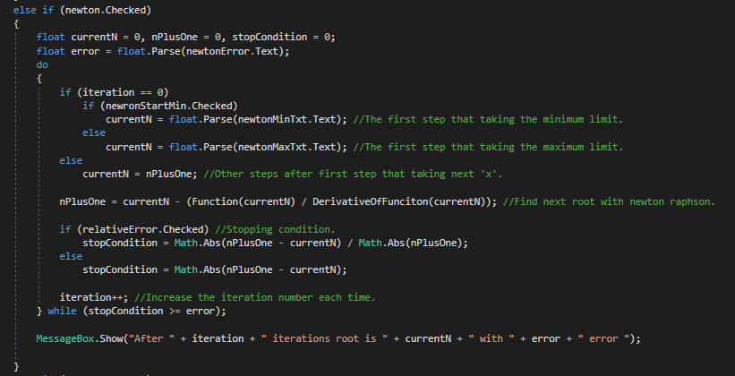

Codes in the second image for Newton raphson method. It applies the method until the root is smaller than acceptable error.

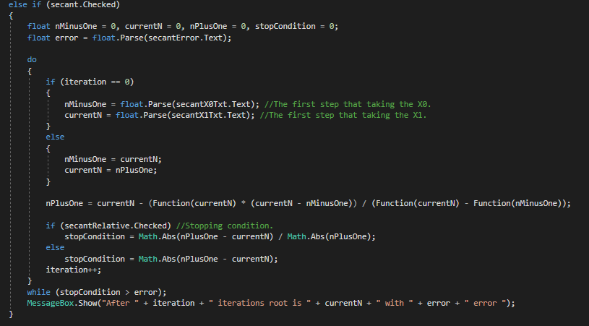

Codes in the third image for secant method. It applies the method until the root is smaller than acceptable error.

**How to use the program?**

First you need to install the program.

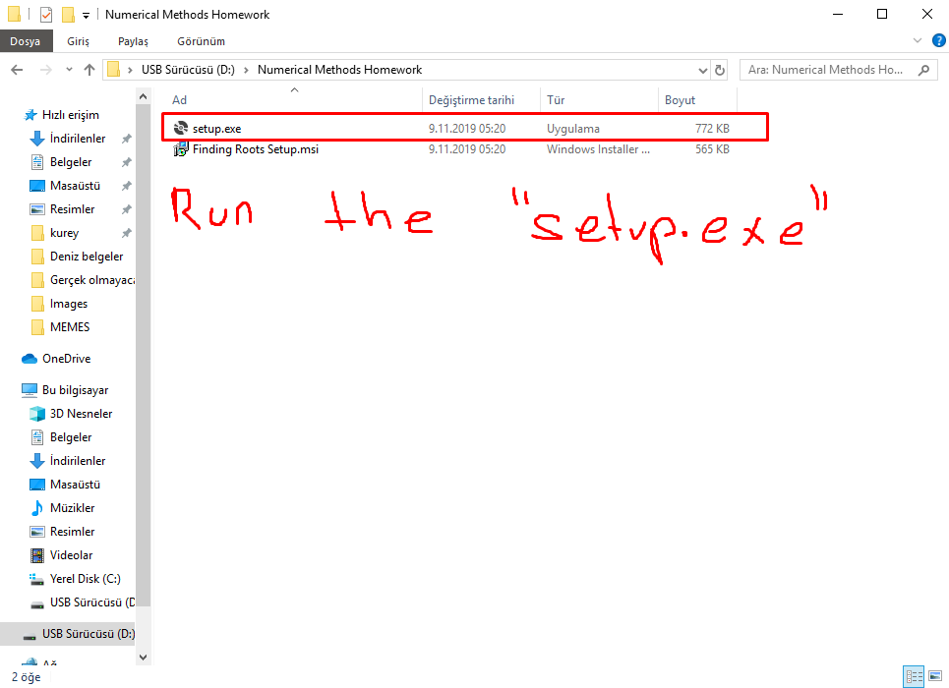

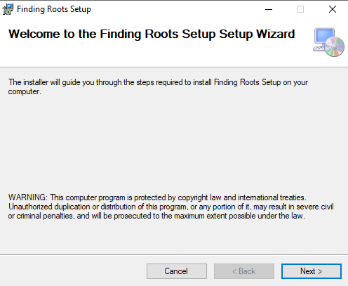

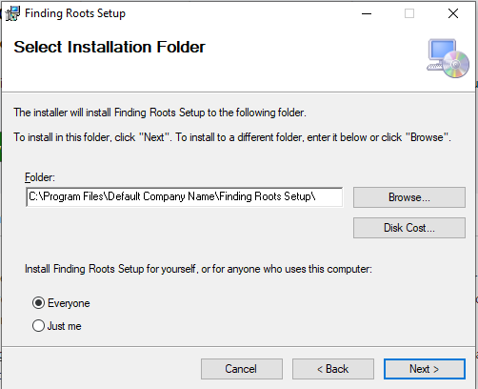

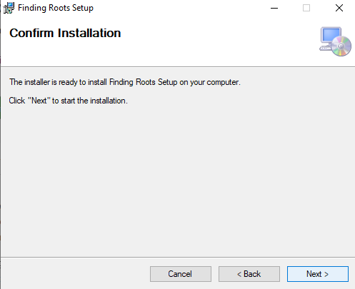

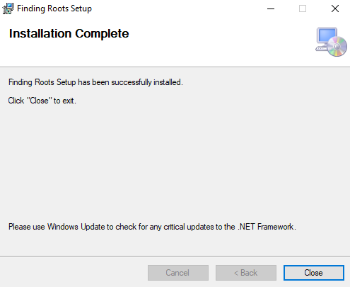

**And done!**

**Select the method that you want and fill the required fields.**

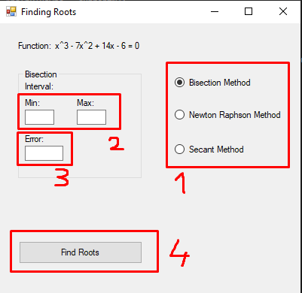

**Student Number:** B1905.010087

**Name:** Kureyş Alp Kılıç